Prime numbers

Here you can see the function that shows if the number is prime or not.
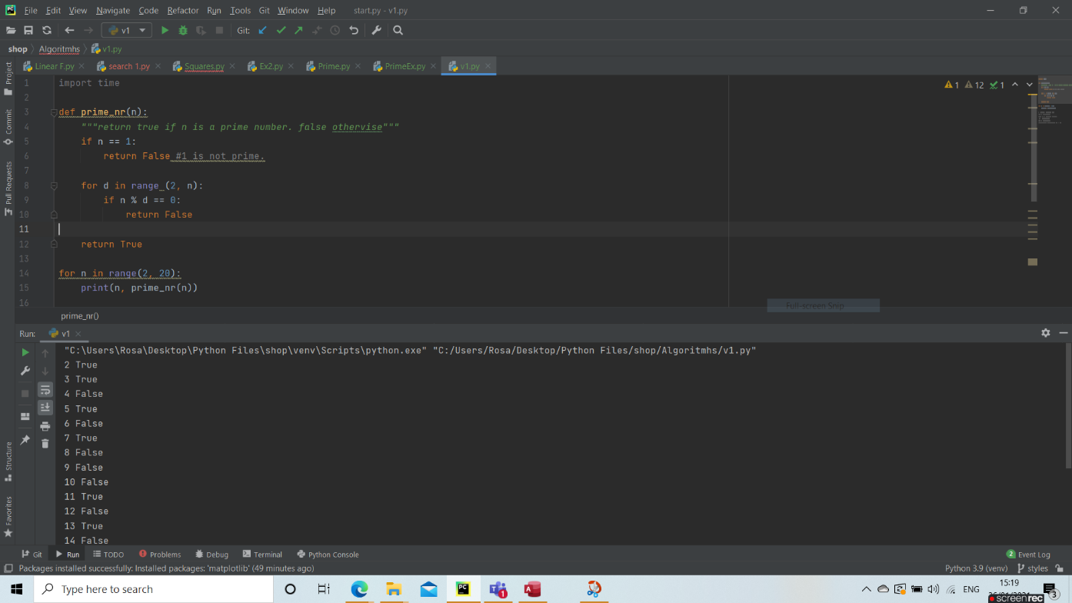

By adding the time function we can see how it affects the programs running time, depending on the number.
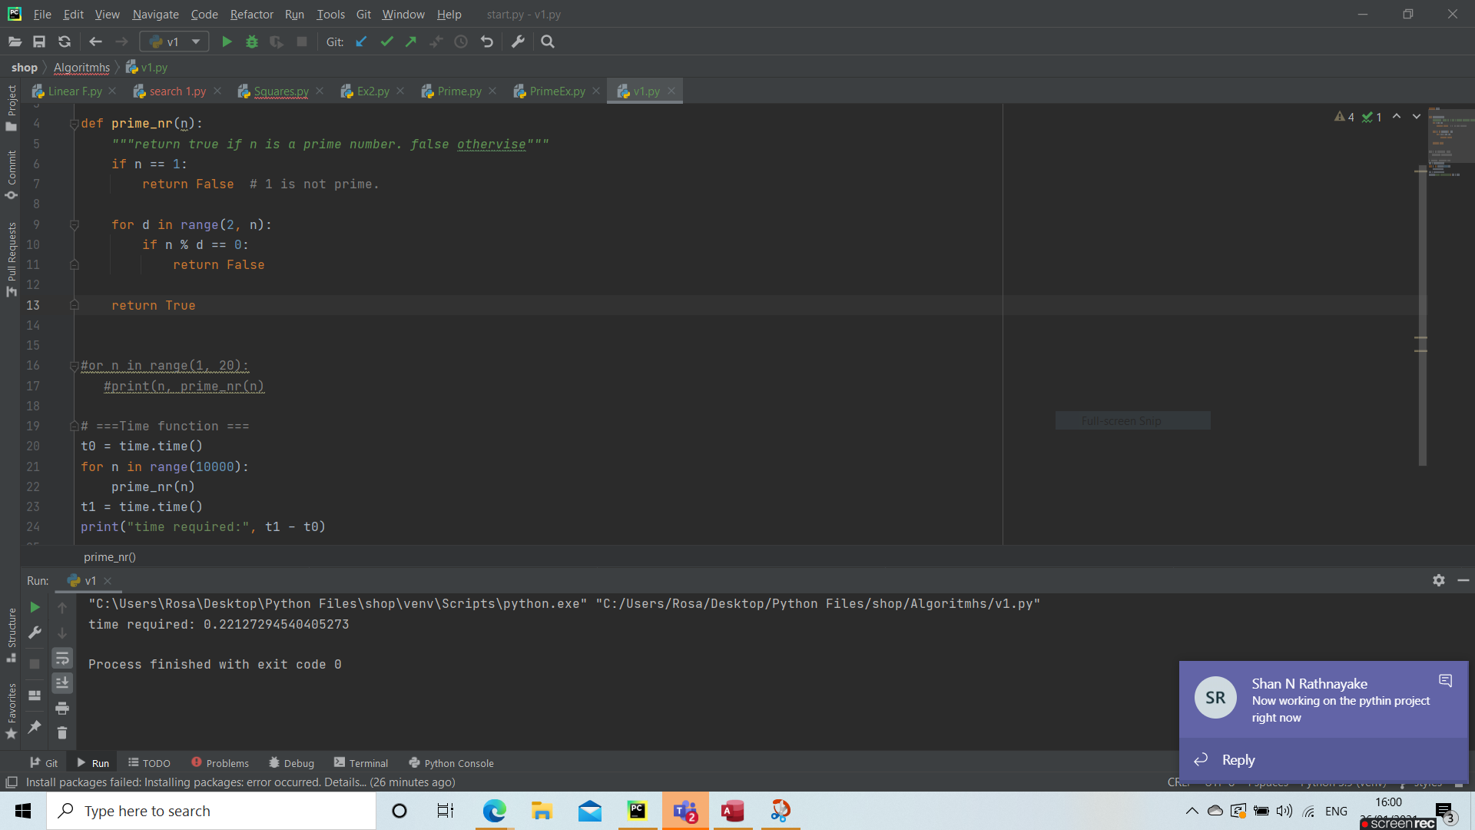
By increasing the range number, the running time grows significantly.
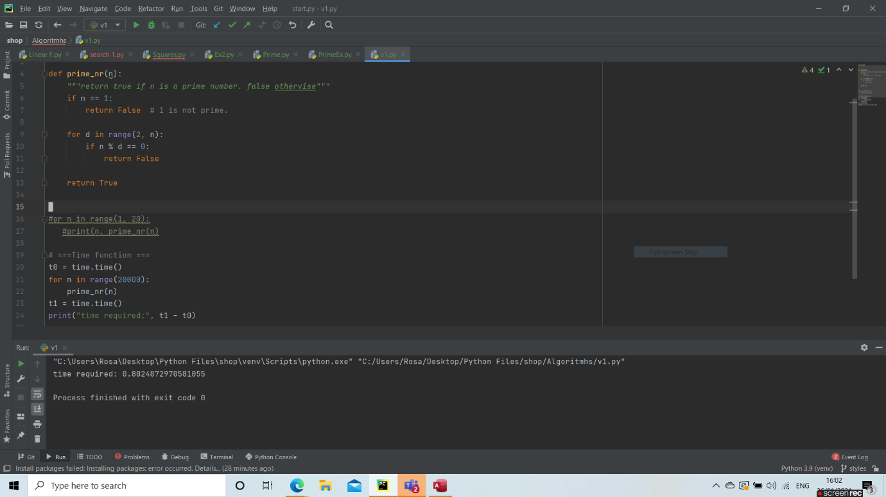
As you can see, this function is not the best, as in bigger number cases, the running time is very high.
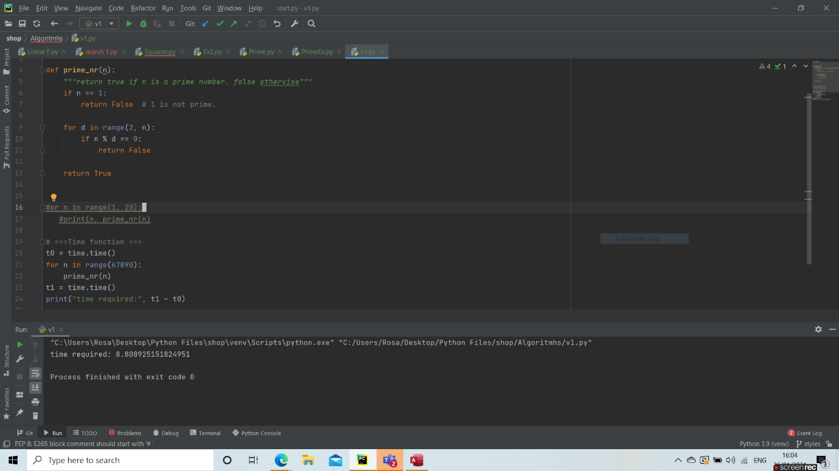

As you can see, my code is not very efficient, as it takes a very long time to run it.

